ISD TERM PROJECT
<Requirements Specification>

<Project Title>



Project Advisor

M.Kashif

Presented by:
Group ID: xxxxxxx

Student Reg# Student Name

Faculty of Information Technology

University of Central Punjab

Software Requirements Specification

Version <Version #>

RideSmart

Advisor: M.Kashif

Member Name | Primary Responsibility | % Contribution | Roll No | Serial # | Sign
M.Faizan Akbar | Intro + Description | 33 | L1F23BSCS0277
M.Hamza Khan | Project Mng + Functional Requir | 33 | L1F23BSCS0279
M.Abuzar | Non Functional + Design + Estimation | 34 | L1F23BSCS0289

Table of Contents
Table of Contents iii
1. Introduction and Background 1
1.1 Product (Problem Statement) 1
1.2 Background 1
1.3 Scope 1
1.4 Objective(s)/Aim(s)/Target(s) 1
1.5 Challenges 1
1.6 Learning Outcomes 2
1.7 Nature of End Product 2
1.8 Completeness Criteria 2
1.9 Business Goals 2
1.10 Related Work/ Literature Survey/ Literature Review 2
1.11 Document Conventions 2
2. Overall Description 4
2.1 Product Features 4
2.2 User Classes and Characteristics 4
2.3 Operating Environment 4
2.4 Design and Implementation Constraints 4
2.5 Assumptions and Dependencies 5
3. Project Management. 6
3.1 Work Breakdown Structure (WBS). 6
3.2 Develop an Activity Graph. Error! Bookmark not defined.
3.3 Find the Critical Path. Error! Bookmark not defined.
3.4 Create a Gantt chart. 8
~~~~~~~~~~ Phase II ~~~~~~~~~~ 8
4. Functional Requirements 8
4.1 Name of Use-Case 1 8
4.2 Name of Use-Case 2 (and so on) Error! Bookmark not defined.
Requirements Analysis and Modeling 12
5. Nonfunctional Requirements* 14
5.1 Performance Requirements 14
5.2 Safety Requirements 14
5.3 Security Requirements 15
5.4 Additional Software Quality Attributes 15
6. Other Requirements 15
7. Designing 18
7.1 Complete class diagram Error! Bookmark not defined.
7.2 Complete Data Flow Diagram (DFD) 18
7.3 Complete ER Diagram 20
7.4 Physical design of your database 20
7.5 Information on use of design patterns while designing the modules Error! Bookmark not defined.
7.6 Make a Sequence and a Collaboration diagram of following. Error! Bookmark not defined.
7.6.1 Scenario 1 Error! Bookmark not defined.
7.6.2 Scenario 2 Error! Bookmark not defined.
8. Estimation 28
8.1 Cost Benefit Estimation 28
8.1.1 Return of Investment (ROI) {1st year} 28
8.1.2 %gain on ROI {1st year} 28
8.1.3 Payback Period in years 28
8.2 FP based Estimation 29
8.3 COCOMO Estimation 29
9. References 30
Appendix A: Glossary 32
Revision History
Name | Date | Reason For Changes | Version

Introduction and Background
Existing ride-hailing applications provide ride matching primarily based on proximity, often resulting in drivers receiving irrelevant ride requests that are far from their preferred working areas or intended destinations. This causes increased fuel consumption, unnecessary ride rejections, and reduced driver satisfaction.

Product (Problem Statement)
The proposed system, RideSmart, addresses this problem by enabling drivers to select their preferred working area and destination-based ride filters, ensuring that drivers receive only relevant ride requests aligned with their route.

Background
Ride-hailing platforms have revolutionized urban transportation by connecting riders and drivers through mobile applications. However, most platforms prioritize rider convenience while offering limited operational control to drivers. In congested cities, drivers often wish to work within a specific area or move towards a desired destination. The lack of such filtering mechanisms motivates the development of a driver-centric ride-hailing solution.

Scope
The scope of this project includes the development of a mobile-based ride-hailing application that allows riders to request rides and drivers to accept them based on proximity, preferred working area, and destination direction. The system supports real-time location tracking, fare negotiation, secure authentication, and ride history management.

Objective(s)/Aim(s)/Target(s)
• To develop a ride-hailing application similar to existing platforms
• To introduce area-based ride selection for drivers
• To enable destination-based ride filtering
• To reduce unnecessary ride rejections
• To improve fuel efficiency and driver satisfaction

Challenges
• Accurate GPS-based location tracking
• Efficient real-time ride filtering
• Handling multiple concurrent ride requests
• Ensuring system scalability

Learning Outcomes
• Understanding requirement engineering
• Designing use-case based systems
• Applying UML and DFD modeling
• Learning project estimation techniques

Nature of End Product
The end product will be a mobile application supported by backend services for real-time ride matching and data management.

Completeness Criteria
The project will be considered complete when all functional and non-functional requirements are implemented, tested, and documented with diagrams and estimations.

Business Goals
• Reduce driver operational costs
• Increase ride acceptance rate
• Provide competitive advantage through innovation

Related Work/ Literature Survey/ Literature Review
Several ride-hailing platforms such as Uber, Careem, and inDrive offer proximity-based ride matching. However, limited support exists for destination-based filtering, highlighting a gap addressed by this project.

Document Conventions
This Software Requirements Specification follows standard documentation conventions to ensure clarity, consistency, and readability throughout the document.

Formatting Conventions
- Bold text is used for section headings, key terms, and emphasis.
- Italic text is used to indicate system modules or concepts.
- Monospaced text may be used where technical labels, keywords, or database fields appear.

Requirement Types
- FR-XXX denotes Functional Requirements
- NFR-XXX denotes Non-Functional Requirements
- UC-XX denotes Use Case identifiers

Diagrams & Models
- Unified Modelling Language (UML) notation is used for:
  - Class diagrams
  - Sequence diagrams
  - Collaboration diagrams
- Data Flow Diagrams follow Gane & Sarson notation:
  - External entities: squares
  - Processes: rounded rectangles
  - Data stores: open-ended rectangles
  - Data flow: arrows
- ERD follows Chen notation:
  - Entities represented by rectangles
  - Attributes implied within description
  - PK and FK indicated in table definitions

Terminology & Naming
- Terms such as Rider, Driver, Admin, Ride, and Payment represent system roles and objects consistently across the document.
- The term Ride Smart refers to the proposed application.
- All time units are represented in 24-hour format when relevant.

Reference Style
- References follow APA formatting style and are listed in Section 9.
- Zotero Reference Manager was used to maintain citations.

Overall Description

Product Features
• User registration and login
• Ride request creation
• Fare negotiation
• Real-time GPS tracking
• Area-based ride filtering
• Destination-based ride filtering
• Ride history and earnings

User Classes and Characteristics

User | Description
Rider | Requests rides and tracks drivers
Driver | Accepts rides and sets filters
Admin | Manages system and users

Operating Environment
• Android / iOS smartphones
• Backend server with database
• Internet connectivity

Design and Implementation Constraints
• Use of GPS services
• Secure authentication required
• Limited mobile device resources

Assumptions and Dependencies
- Users have smartphones with GPS
- Google Maps API availability
- Stable internet connection

Project Management.

Work Breakdown Structure (WBS).

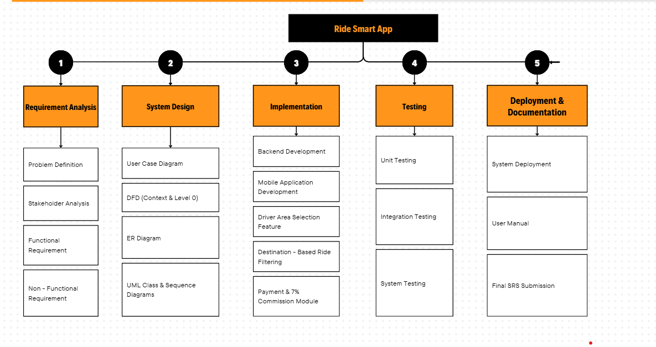

3.2 Find The Activity Graph.

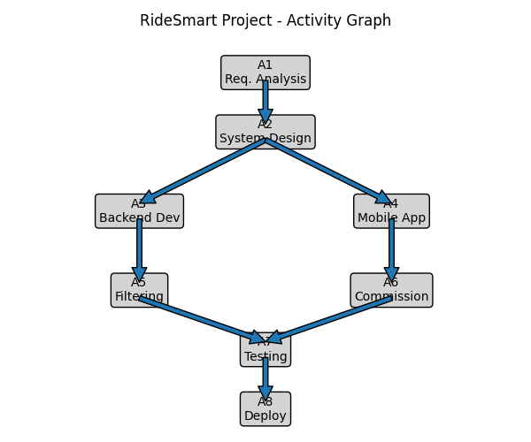

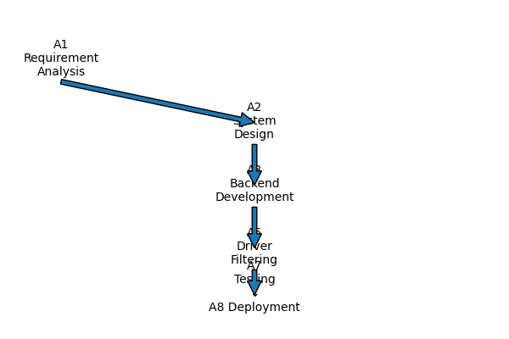
3.3 Find The Critical Path.

3.3 Create Gantt Chart.

~~~~~~~~~~ Phase II ~~~~~~~~~~

Functional Requirements
<All functional requirements are expressed as use-cases. Fill out the following template for each use-case. Don’t really say “Use-Case 1.” State the use-case name in just a few words e.g. “Withdraw Cash from ATM”. A use-case may have multiple alternate courses of action.>

<Provide a Use Case Diagram before describing the use cases.>

Name of Use-Case 1

3.4 Create a Gantt chart.
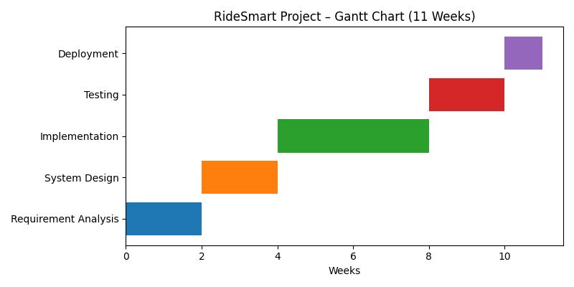

The use case diagram includes the following actors and interactions:
- Rider: Register, Login, Request Ride, Cancel Ride, Make Payment, View Ride History
- Driver: Register, Login, Set Working Area, Set Destination Direction, Accept Ride, Complete Ride, View Earnings
- Admin: Manage Users, Monitor Rides, View Commission Reports

Identifier |  | UC-1
Purpose |  | Rider , Driver
Priority |  | High
Pre-conditions |  | User is not registered in the system
Post-conditions |  | User account is successfully created
Typical Course of Action
S# | Actor Action |  | System Response
1 | User enter registration details |  | System validates data
2 | User submits form |  | Account is created
3 | User receives confirmation |  | Login enabled
…

Identifier |  | UC-2
Purpose |  | Rider , Driver
Priority |  | High
Pre-conditions |  | User is registered
Post-conditions |  | User is authenticated
Typical Course of Action
S# | Actor Action |  | System Response
1 | User enter credentials |  | System verifies data
2 | User clicks login |  | Dashboard displayed
3 | User receives confirmation |  | Login enabled
…
Alternate Course of Action
S# | Actor Action |  | System Response
1 | User enters incorrect password |  | System display error message
2 | User retries login |  | System revalidated credentials
3 | Attempts exceed 3 tries |  | Account temporarily locked
…

Identifier |  | UC-3
Purpose |  | Rider
Priority |  | High
Pre-conditions |  | Rider is logged in
Post-conditions |  | Ride request is created
Typical Course of Action
S# | Actor Action |  | System Response
1 | Enter pickup & drop-off |  | System Calculated route
2 | Submit ride request |  | Nearby drivers notified
3 | User receives confirmation |  | Login enabled
…
Alternate Course of Action
S# | Actor Action |  | System Response
1 | Rider request sent, but no drivers available |  | System displays “No drivers near you”
2 | Rider modifies destination/fare |  | System resends updated ride request
3 | Rider cancels request before driver responds |  | System marks ride as cancelled and notifies drivers
…

Identifier |  | UC-4
Purpose |  | Driver
Priority |  | High
Pre-conditions |  | Driver is logged in.
Post-conditions |  | Working area is saved.
Typical Course of Action
S# | Actor Action |  | System Response
1 | Select working area |  | Area saved
2 | Confirm selection |  | Filter activated
3 | User receives confirmation |  | Login enabled
…
Alternate Course of Action
S# | Actor Action |  | System Response
1 | Driver selects invalid or unsupported area |  | System shows error/Not supported
2 | Driver tries to set multiple areas |  | System asks to confirm override
3 | Driver cancels area selection |  | System keeps previous saved area
…

Identifier |  | UC-5
Purpose |  | Driver
Priority |  | High
Pre-conditions |  | Driver is logged in.
Post-conditions |  | Destination filter is enabled.
Typical Course of Action
S# | Actor Action |  | System Response
1 | Select destination direction |  | System stores preference
2 | Enable filter |  | Relevant rides displayed
3 | User receives confirmation |  | Login enabled
…
Alternate Course of Action
S# | Actor Action |  | System Response
1 | Driver enter too far/unreachable direction |  | System shows warning
2 | Driver switches filter OFF |  | System resumes normal ride matching
3 | Driver changes destination during trip |  | System updates filter and resets matching
…

Identifier |  | UC-6
Purpose |  | Driver
Priority |  | High
Pre-conditions |  | Ride request is available
Post-conditions |  | Ride is assigned to driver
Typical Course of Action
S# | Actor Action |  | System Response
1 | Driver select ride |  | System validates data
2 | Confirm acceptance |  | Rider notified
3 | User receives confirmation |  | Login enabled
…
Alternate Course of Action
S# | Actor Action |  | System Response
1
2
3
…

Requirements Analysis and Modeling
Use Case Diagram :

The use case diagram identifies three primary actors:

- Rider
- Driver
- Admin

The main use cases include:

- Request Ride
- Accept/Reject Ride
- Set Working Area & Destination Filter (driver)
- Complete Ride
- Payment & 7% Commission
- View Ride History
- Admin Monitoring

States :

State | Meaning
Requested | Rider submits ride request
Accepted | Driver has accepted
In-Progress | Ride is ongoing
Completed | Trip has ended
Cancelled | Rider/Driver terminated
Closed | Payment & Commission cleared
Expired | Timed out without driver
Payment failed | Retry required

Decision Table :

Condition Logic for Showing a Ride to a Driver

Condition | Working Area Match? | Destination Direction Match? | Show Ride?
C1 | Yes | Yes | Yes
C2 | Yes | No | Optional / Driver Chooses
C3 | No | Yes | No
C4 | No | No | No
C5 | Filter Off | N/A | Yes (normal mode)

Event Table :

Event | Trigger | Source | System response | Output
Rider logs in | User taps login | Rider | Authenticate | Rider Dashboard
Driver sets area | Driver updated profile | Driver | Save new area filter | Confirm message
Rider requests ride | Submit pickup / drop | Rider | Create ride + notify drivers | Ride pending
Driver accepts ride | Click accept | Driver | Assign driver | Rider updated
Ride starts | Driver presses START | Driver | Change state | Live tracking
Ride ends | Driver presses END | Driver | Compute fare & commission | Amount split
Payment Processed | Gateway approves | Payment API | Update status | Receipt + Driver wallet
Payment fails | Decline from bank | Payment API | Retry / Notify admin | Pending Payment
Admin Reviews Data | Admin Logs In | Admin | Generate Usage Report | Display Analytics

Nonfunctional Requirements

Performance Requirements
- The system shall respond to user requests (login, ride request, ride filtering) within 3 seconds under normal network conditions.
- The system shall support at least 1,000 concurrent users without performance degradation.
- Ride matching and destination-based filtering shall complete within 2 seconds after a ride request is created.
- The system shall update driver and rider location data in real time (every 5 seconds).
- Payment and commission calculation (7%) shall be completed within 2 seconds after ride completion.

Safety Requirements
- The system shall allow riders to cancel rides in case of emergencies.
- The system shall maintain verified driver profiles to ensure rider safety.
- The system shall store complete ride history to assist in dispute resolution.
- The system shall prevent drivers from accepting multiple rides simultaneously.
- The system shall allow admins to suspend accounts in case of safety violations.

Security Requirements
- The system shall require secure authentication for all users.
- User credentials shall be stored using encrypted password hashing.
- All payment-related data shall be transmitted using secure communication protocols (HTTPS).
- Only authorized admins shall access commission and financial reports.
- The system shall ensure data privacy for user location and personal details.

Additional Software Quality Attributes
- The system shall maintain an uptime of at least 99%.
- The system shall automatically recover from minor system failures.
- Ride data shall not be lost in case of temporary network disconnection.
- The system shall perform automatic daily database backups.

Other Requirements

Usability Requirements
- The application shall provide a simple and intuitive user interface.
- Drivers shall be able to set their working area and destination filter in less than three steps.
- The system shall display clear ride information including pickup, drop-off, and fare.
- The application shall support users with minimal technical knowledge.

Scalability Requirements
- The system shall support future expansion to multiple cities.
- The system shall handle an increasing number of users without major redesign.
- The database shall be scalable to store long-term ride and payment data.

Maintainability Requirements
- The system shall follow modular architecture for easy maintenance.
- New features shall be added without affecting existing functionality.
- Code shall follow standardized coding conventions and documentation.

Availability Requirements
- The system shall be available 24/7, except during scheduled maintenance.
- Scheduled maintenance shall not exceed 2 hours per month.
- Users shall be notified before any planned downtime.

Portability Requirements
- The application shall be deployable on both Android and iOS platforms.
- Backend services shall be platform independent.
- The system shall support deployment on cloud infrastructure.

Legal and Regulatory Requirements
- The system shall comply with local data protection laws.
- Payment processing shall comply with standard financial security practices.
- User consent shall be obtained before collecting location data.

Designing

Complete Class Diagram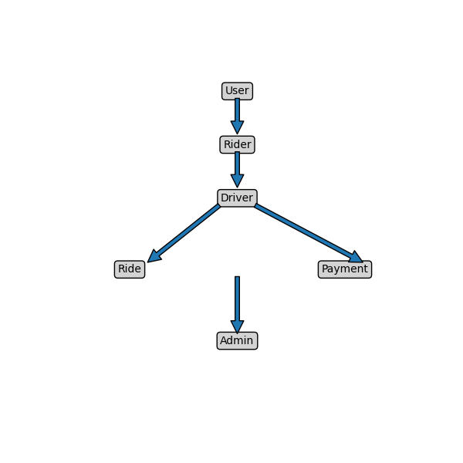

Complete Data Flow Diagram (DFD)
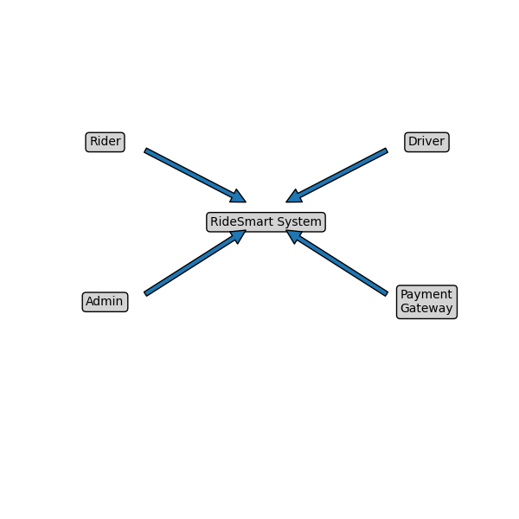

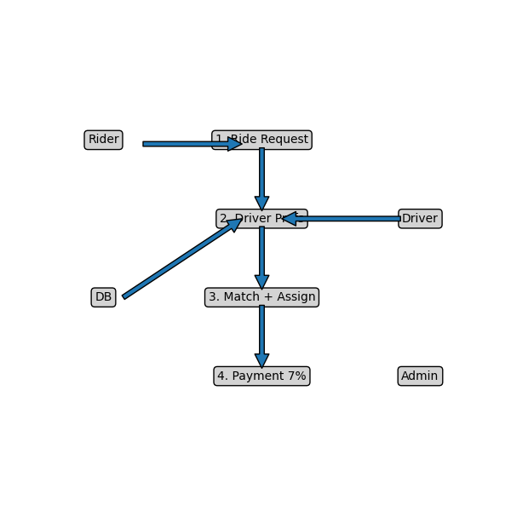

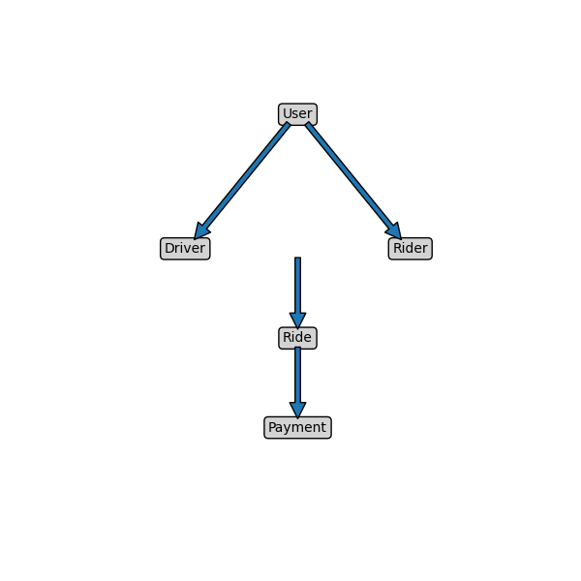
Complete ER Diagram

Scenario & Collaboration Diagram
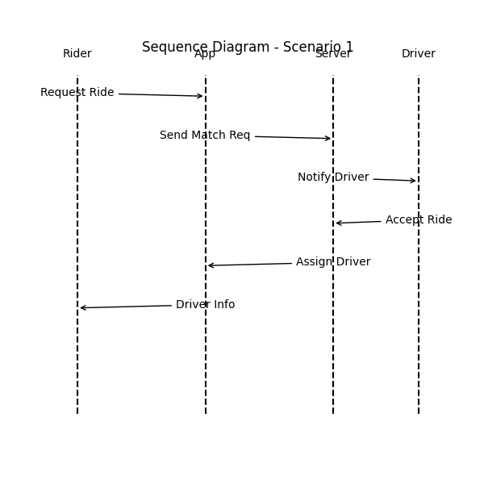

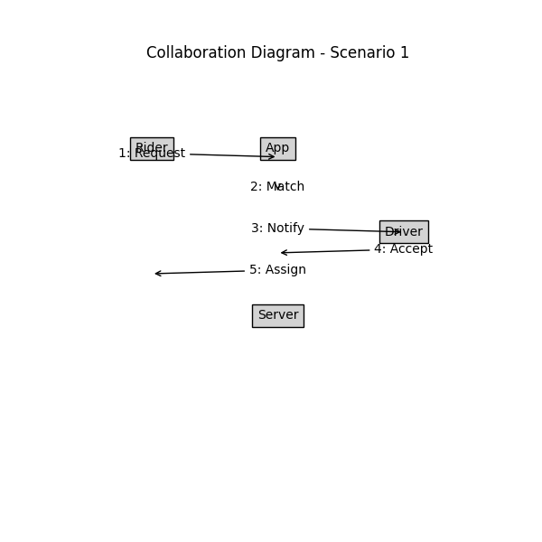

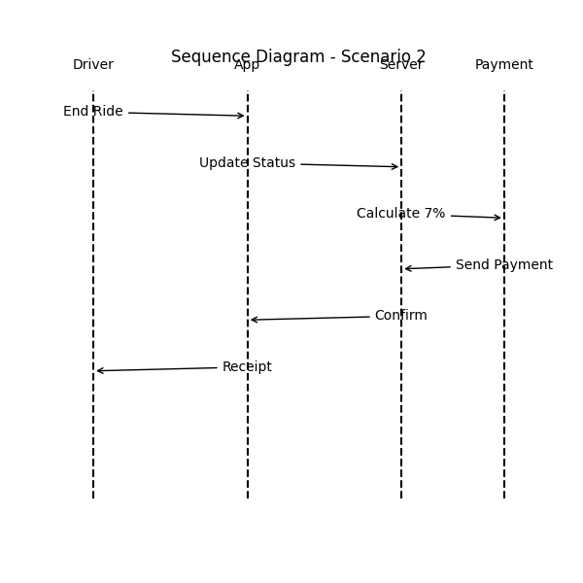

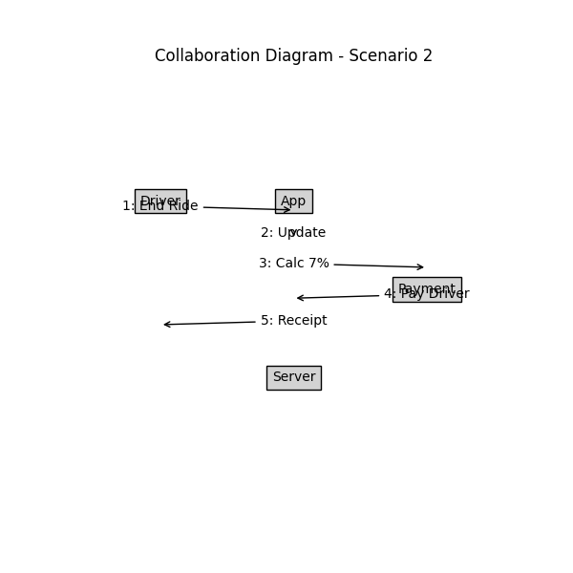

Physical Design Of the Database

User

Field | Type | Description
User-id(PK) | INT | Unique user identifier
Name | VARCHAR(100) | Full name
Phone | VARCHAR(20) | Contact number
Email | VARCHAR(100) | Login/notification email
Password | VARCHAR(255) | Encrypted password
Role | ENUM | Determines permission level

Driver

Field | Type | Description
Driver-id(PK) | INT | Unique driver id
User-id(FK) | INT | Links to user table
Vehicle-info | VARCHAR(100) | Vehicle number/model
Working-area | VARCHAR(100) | Selected operating area
Destination-filter | VARCHAR(100) | Selected direction or destination
Availibility | BOOL | Whether driver is online/offline

Ride

Field | Type | Description
Ride-id(PK) | INT | Unique ride record
Ride_id(PK) | INT | Links to user table
Driver_id(FK) | INT | Assigned driver
Pickup-location | VARCHAR(150) | Starting point
Drop – location | VARCHAR(150) | Ending point
Fare | INT | Calculated ride cost
Ride status | ENUM | State of ride
Time stamp | DATETIME | When ride was created

Payment
Field | Type | Description
Payment-id(PK) | INT | Unique payment record
Ride-id(FK) | INT | Associated ride
Total-amount | INT | Full fare paid
Commission-amount | INT | Platform fee (7%)
Driver-amount | INT | Paid to driver
Payment-status | ENUM | Current payment state

Admin

Field | Type | Description
Admin-id(PK) | INT | Unique admin identifier
Name | VARCHAR(100) | Admin name
Email | VARCHAR(100) | Login/contact

Information on Use of Design Patterns

The application utilizes well-known software design patterns to ensure scalability, code maintainability, and modular structure.

1. Model-View-Controller (MVC) Pattern
Purpose: Separates the system into logical layers
- Model (Data + Business Logic):
  - User
  - Driver
  - Ride
  - Payment
- View (UI Screens):
  - Rider mobile app
  - Driver mobile app
  - Admin dashboard
- Controller (Brain/Logic):
  - RideController
  - DriverFilterController
  - PaymentController
✔ MVC ensures UI changes do not affect core logic and vice versa.

2. Singleton Pattern
Where used:
- Database Connection Handler
Only a single instance of DB connection is created and used throughout the system, reducing errors and resource load.

3. Observer / Event Notification Pattern
Where used:
- Ride request → notify available drivers
The system pushes a notification to drivers when:
- Rider requests ride
- Ride matches their filters
- Driver accepts or rejects ride

4. Strategy Pattern (Optional but relevant)
Where used:
- Fare calculation and commission deduction
Different pricing rules can be applied later:
- Night rate
- Surge pricing
- Distance-based pricing

All handled by interchangeable calculation strategies.

5. Factory Pattern (Optional mention)
If implemented:
- Creating objects like Ride, Payment, User instances without exposing logic

Summary Statement
The system leverages MVC for architectural separation, Singleton for database connection, Observer for real-time driver notification, and Strategy for flexible fare and commission computation, ensuring modularity, extensibility, and maintainability.

Estimation
This section provides an approximate estimation of cost, effort, schedule, and benefits of the proposed RideSmart ride-hailing application. The estimations are based on reasonable assumptions for a medium-scale academic software project.

Cost Benefit Estimation

Return of Investment (ROI) {1st year}
Cost Component | Estimated Cost (PKR)
Requirement Analysis | 80,000
System Design (UML, DFD, ERD) | 70,000
Development & Coding | 200,000
Testing & Debugging | 60,000
Documentation & Deployment | 40,000
Total Estimated Cost | 450,000 PKR

%gain on ROI {1st year}
The application generates revenue through a 7% commission per completed ride.
Assumptions:
- Average rides per day = 120
- Average fare per ride = PKR 500
- Daily commission = 120 × 500 × 7% = PKR 4,200
- Monthly commission ≈ PKR 126,000
- Yearly commission ≈ PKR 1,512,000
👉 Estimated Annual Benefit = PKR 1,500,000

Payback Period in years
Formula:
ROI = Benefits / Cost
ROI = 1,500,000 / 450,000
ROI Ratio = 3.33
ROI Percentage = (Net Profit / Cost) × 100 = 233%
This indicates that the project is financially viable and profitable.

FP based Estimation

8.2.1 Function Point Identification

Component | Count
External Inputs (Login, Ride Request, Area Selection) | 8
External Outputs (Ride Confirmation, Reports) | 6
External Inquiries | 5
Internal Logical Files | 5
External Interface Files | 2

8.2.2 Total Function Points
Estimated Unadjusted Function Points (UFP) = 120 FP
Using average complexity:
Adjusted Function Points ≈ 130 FP

8.2.3 Effort Estimation Using FP
Assumption:
- Productivity rate = 10 FP / person-month
Effort = 130 / 10
Effort ≈ 13 person-months

COCOMO Estimation
The project is categorized as an Organic Model, as it is a small-to-medium size application developed by a small team.

8.3.1 Basic COCOMO Formula
Effort (PM) = a × (KLOC)^b
Where:
- a = 2.4
- b = 1.05
- Estimated Size = 25 KLOC
Effort = 2.4 × (25)^1.05
Effort ≈ 12 person-months

Development Time Estimation
Time = 2.5 × (Effort)^0.38
Time ≈ 2.5 × (12)^0.38
Time ≈ 6 months

8.4 Summary of Estimation

Estimation Type | Result
Development Cost | PKR 450,000
Annual Benefit | PKR 1,500,000
ROI | 3.33
% Gain on ROI | 233%
Payback Period | 0.3 years
Effort | 12-13 person-months
Development Time | 6 months

References
• Sommerville, I. (2016). Software Engineering (10th ed.). Pearson Education Limited.
• Pressman, R. S., & Maxim, B. R. (2020). Software Engineering: A Practitioner’s Approach (9th ed.). McGraw-Hill Education.
• IEEE Computer Society. (2018). IEEE Standard for Software Requirements Specifications (IEEE 830-1998). IEEE.
• Google Developers. (2024). Google Maps Platform Documentation. https://developers.google.com/maps
• Uber Technologies Inc. (2024). Ride-Hailing System Overview. Retrieved from
https://www.uber.com
• inDrive. (2024). How inDrive Works – Ride Sharing Model. Retrieved from
https://indrive.com
• Yango. (2024). Urban Mobility and Ride-Hailing Solutions. Retrieved from
https://yango.com
• Kendall, K. E., & Kendall, J. E. (2019). Systems Analysis and Design (10th ed.). Pearson Education.
• University of Central Punjab. (2024). ISD Course Material and SRS Guidelines. Faculty of Information Technology, UCP.

Appendix A: Glossary
This glossary defines the technical terms, abbreviations, and concepts used throughout this SRS to ensure consistent understanding.

A
Admin
A system user with full privileges, responsible for monitoring rides, resolving disputes, managing users, and viewing financial reports.

C
Commission (7%)
The percentage of ride fare retained by the Ride Smart platform as revenue on every completed ride. The remaining amount is transferred to the driver.
Collaboration Diagram
A UML diagram showing objects interacting in a system, focusing on the relationship between them.
Context Diagram
A high-level data flow diagram that shows the entire system as a single process with external inputs and outputs.

D
DFD (Data Flow Diagram)
A visual representation that illustrates how data moves through the system, including input, processing, storage, and output.
Destination Filter
A feature allowing drivers to specify the area or direction they want to travel so they only receive relevant ride requests.
Driver
A registered ride provider who receives requests from riders, selects rides, completes trips, and earns payment.

E
ERD (Entity Relationship Diagram)
A model used to represent system data entities, attributes, and relationships among them.
End User
A person actively using the system — either a rider requesting rides or a driver accepting them.

F
Functional Requirements
Statements describing what the system must do — the behaviour, features, and functions.

L
Location Tracking
The process of collecting and updating the real-time geographical location of riders and drivers.

N
Non-Functional Requirements
Requirements that define quality attributes such as performance, reliability, security, and scalability.

P
Payment Gateway
External service provider responsible for securely handling fare transactions between riders, drivers, and the system.

R
Rider
A customer who requests transportation using the app, selects pick-up and drop-off points, and pays the fare.
Ride Request
A service request initiated by a rider, containing pickup location, drop-off location, and desired ride details.
RideSmart
The proposed ride-hailing system being developed in this project.

S
Sequence Diagram
A UML model showing step-by-step object interaction over time.
Stakeholder
Anyone who has an interest in the system, including riders, drivers, admin, and developers.

U
UML (Unified Modelling Language)
A standardized visual language used to represent software structure and behaviour using diagrams such as class, sequence, and collaboration diagrams.
Use Case
A structured description of how users interact with the system to achieve goals.

W
Working Area
The geographic zone a driver selects to receive rides only from that area.

